Day 20
Sprint 1 Submission
Name: Mriganka Patra
Emp ID: 2415820
Email: Mriganka.Patra@cognizant.com

Task:
Write and execute manual test cases for SharePoint forms.

Manual Test Cases:
Test Case 4: Form Cancellation
Description: Verify that the form can be cancelled without creating an item.

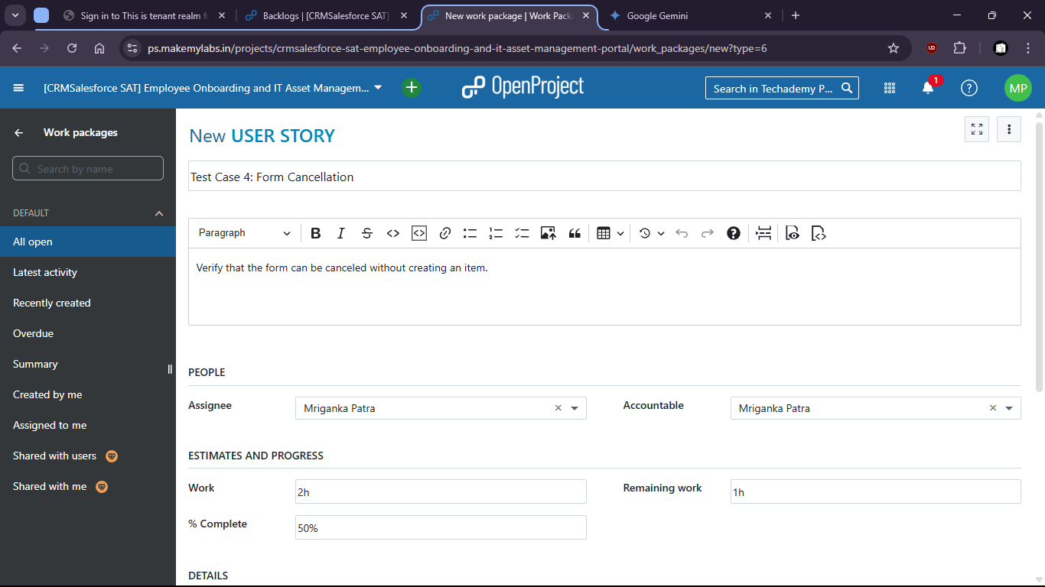

Form is filled up
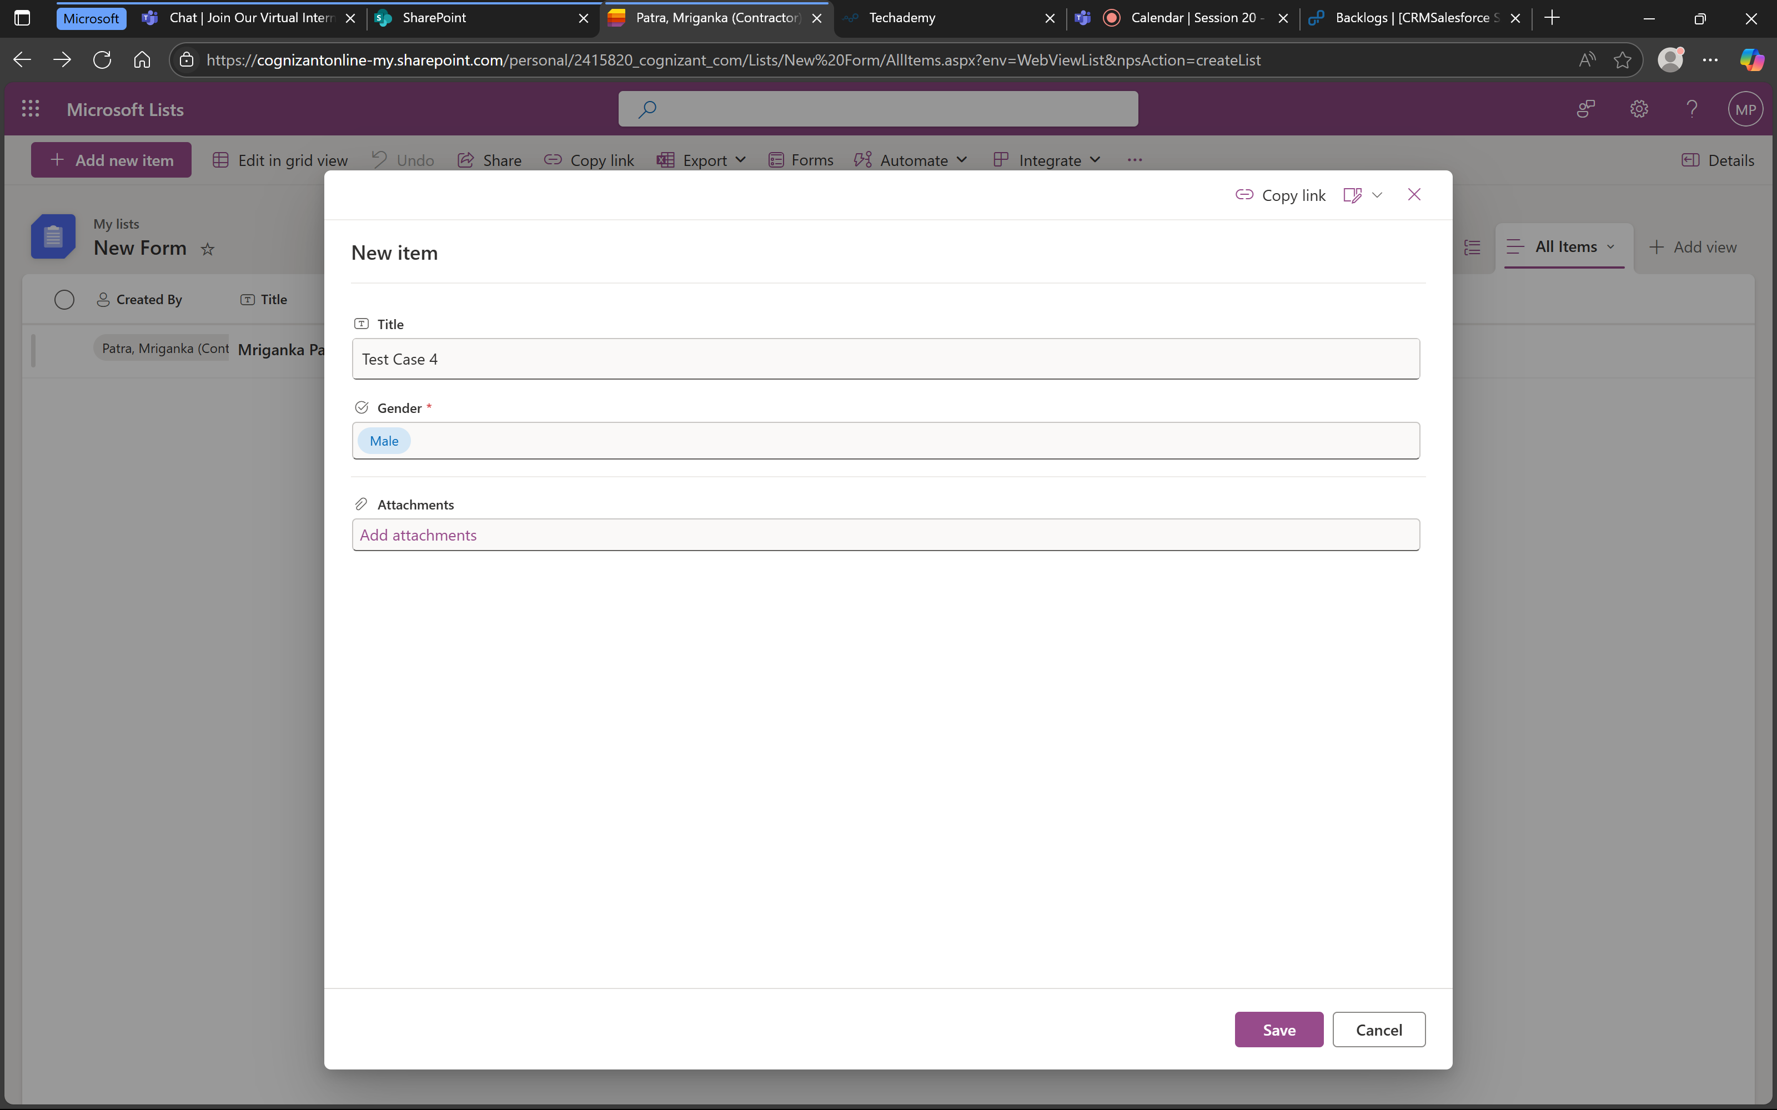

Then it is cancelled:
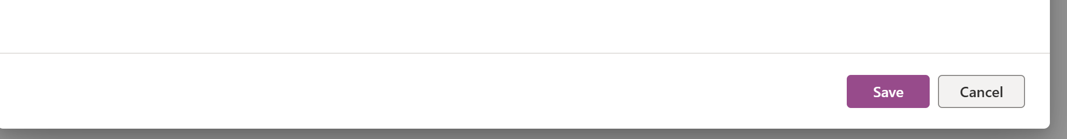

We can check that no new form is created

